

**ATM MANAGEMENT SYSTEM**

**A PROJECT REPORT**

**Submitted by**

**BELLAMKONDA__NAGESWAR__YADAV**

**192372005**

**Under the guidance of**

**Dr.D.VINOTH**

**Capstone project-CSA0377-DATA STRUCTURES FOR PROCESS SCHEDULING**

**in partial fulfilment for the completion of Course**

**BONAFIDE CERTIFICATE**

**Certified that this project report titled** "ATM MANAGEMENT SYSTEM" is the Bonafide work “**BELLAMKONDA__NAGESWAR__YADAV”,**who carried out the project work under my supervision as a batch. Certified further, that to the best of my knowledge the work reported herein does not form any other project report.

Date:

Project Supervisor Head of the Department

**TABLE AND CONTENTS: -**

|  |  |  |
| --- | --- | --- |
| **S.NO** | **TOPICS** | **PAGE.NO** |
| **1** | **ABSTRACT** |  |
| **2** | **INTRODUCTION** |  |
| **3** | **PROPOSED SYSTEM DIAGRAM** |  |
| **4** | **SIMULATOR DETAILS** |  |
| **5** | **SIMULATION OUTPUT** |  |
| **6** | **ADVANTAGES & DISADVANTAGES** |  |
| **7** | **CONCLUSION** |  |
| **8** | **REFERENCES** |  |

**Aim:**

An ATM management system aims to streamline and secure the operations of ATMs by handling transaction processing, monitoring machine status, and managing cash levels efficiently. It ensures reliable user authentication, data integrity, and optimal functionality of ATM networks.

**Objectives:**

An ATM management system aims to streamline and secure the operations of ATMs by handling transaction processing, monitoring machine status, and managing cash levels efficiently. It ensures reliable user authentication, data integrity, and optimal functionality of ATM networks.

**1. Efficient User Authentication**

**Objective**: To verify the identity of users quickly and securely.

* **Data Structure Used**: Hash Tables
  + **Implementation**: Store user credentials (card number and PIN) in a hash table. Hashing provides quick access and search operations, ensuring rapid user authentication.
  + **Benefit**: Fast lookup times ensure a smooth and swift user experience.

**2. Transaction Management**

**Objective**: To handle various types of transactions efficiently.

* **Data Structure Used**: Queues
  + **Implementation**: Use queues to manage transaction requests. Each ATM machine can have its own queue where transactions are processed in a First-In-First-Out (FIFO) order.
  + **Benefit**: Ensures orderly processing of transactions and handles high traffic efficiently.

**3. Cash Management**

**Objective**: To monitor and manage cash levels in ATMs.

* **Data Structure Used**: Linked Lists
  + **Implementation**: Implement a linked list to keep track of cash denominations (e.g., $20 bills, $50 bills) available in the ATM. Each node can represent a denomination and the quantity available.
  + **Benefit**: Provides dynamic and flexible cash level management, making it easy to add or remove denominations.

**4. Transaction Logging**

**Objective**: To maintain a detailed log of all transactions for audit and troubleshooting purposes.

* **Data Structure Used**: File Handling with Linked Lists
  + **Implementation**: Use linked lists to temporarily store transaction details during operation. At the end of the day or during low traffic periods, write the details to a log file.
  + **Benefit**: Ensures efficient memory usage and reliable logging, with easy-to-maintain structures.

**5. User Account Management**

**Objective**: To manage user account details and balance information securely.

* **Data Structure Used**: Binary Search Trees (BST)
  + **Implementation**: Store user account information in a BST to allow quick search, insert, and delete operations.
  + **Benefit**: Provides an organized way to manage accounts, ensuring that account lookups and updates are efficient.

**6. Real-Time Monitoring and Alerts**

**Objective**: To monitor the status of each ATM and generate alerts for maintenance.

* **Data Structure Used**: Arrays and Priority Queues
  + **Implementation**: Use arrays to monitor the status of various components within each ATM. Priority queues can manage alerts based on severity.
  + **Benefit**: Provides a structured way to monitor real-time status and prioritize maintenance tasks.

**7. Security and Fraud Detection**

**Objective**: To detect and prevent fraudulent activities.

* **Data Structure Used**: Graphs
  + **Implementation**: Represent the network of transactions as a graph, where nodes represent users and edges represent transactions. Analyze the graph for unusual patterns that might indicate fraud.
  + **Benefit**: Enables advanced fraud detection mechanisms, improving overall security.

**8. Reporting and Analytics**

**Objective**: To generate reports and perform analytics on ATM usage and performance.

* **Data Structure Used**: Stacks and Dynamic Arrays
  + **Implementation**: Use stacks to keep track of recent transactions for quick report generation. Dynamic arrays can store statistical data over time.
  + **Benefit**: Facilitates efficient report generation and data analysis, providing insights into ATM performance.

**Introduction:**

An Automated Teller Machine (ATM) Management System is an essential component of modern banking infrastructure, facilitating various financial transactions such as cash withdrawals, deposits, balance inquiries, and fund transfers. Efficient management of these operations is critical to ensure quick, secure, and reliable service for users. Implementing such a system using the C programming language and leveraging appropriate data structures can significantly enhance its performance and robustness.

C is a powerful, low-level programming language that offers fine-grained control over system resources, making it ideal for developing performance-critical applications like an ATM Management System. The choice of data structures in C directly influences the efficiency of different system components, including user authentication, transaction processing, cash management, and security measures.

### Key Components and Data Structures

1. **User Authentication**: Efficient user authentication is paramount for the security of an ATM system. Hash tables are employed to store and quickly retrieve user credentials such as card numbers and PINs. Hashing provides constant time complexity for search operations, ensuring swift validation of user identity.
2. **Transaction Processing**: The system must handle various transactions efficiently. Queues are used to manage transaction requests, processing them in a First-In-First-Out (FIFO) order. This structure ensures that transactions are handled fairly and in a timely manner, even during peak usage.
3. **Cash Management**: Monitoring and managing cash levels in ATMs is crucial to avoid downtime and ensure availability. Linked lists are ideal for representing cash denominations and quantities dynamically. This flexibility allows for easy updates and modifications to the cash inventory.
4. **Transaction Logging**: Maintaining a comprehensive log of all transactions is vital for audit and troubleshooting purposes. Linked lists can temporarily store transaction details before writing them to log files, optimizing memory usage and ensuring reliable data storage.
5. **User Account Management**: Efficient management of user account information is achieved through Binary Search Trees (BST). BSTs allow for quick search, insert, and delete operations, ensuring that account information is accessed and updated efficiently.
6. **Real-Time Monitoring and Alerts**: Arrays and priority queues are used to monitor the status of ATMs and generate maintenance alerts. Arrays provide a straightforward way to track machine components, while priority queues help prioritize alerts based on severity, ensuring prompt attention to critical issues.
7. **Security and Fraud Detection**: Implementing robust security measures is essential to prevent fraud. Graphs can represent the network of transactions, where nodes are users and edges are transactions. Analyzing this graph for unusual patterns helps detect potential fraud, enhancing the overall security of the system.

**Utilized data structures:**

• **Hash Tables**: Used for user authentication by storing user credentials (card number and PIN), enabling quick lookups and secure access.

• **Queues**: Manage transaction requests in a FIFO order, ensuring orderly processing of transactions and efficient handling of high traffic.

• **Linked Lists**: Track cash denominations available in the ATM, providing dynamic and flexible management of cash levels.

• **File Handling with Linked Lists**: Temporarily store transaction details and later write them to log files, ensuring efficient memory usage and reliable transaction logging.

• **Binary Search Trees (BST)**: Store and manage user account information, allowing quick search, insert, and delete operations for account management.

• **Arrays and Priority Queues**: Monitor the status of various ATM components and manage maintenance alerts based on severity.

• **Graphs**: Represent the network of transactions to detect and prevent fraudulent activities by analyzing transaction patterns.

• **Stacks and Dynamic Arrays**: Used for quick report generation and storing statistical data for analytics, facilitating efficient data analysis and performance reporting.

**Advantages in c :**

• **Performance**: C provides high performance due to its low-level capabilities, making it suitable for real-time systems where quick response times are essential.

• **Efficiency**: C allows direct manipulation of hardware and memory, enabling efficient resource management which is crucial for handling large volumes of transactions and data.

• **Portability**: C code is highly portable, meaning it can run on various hardware platforms with minimal modifications, which is beneficial for deploying ATMs in diverse locations.

• **Flexibility**: The language's flexibility allows developers to implement custom data structures and algorithms tailored to specific requirements of ATM management.

• **Control**: C offers fine-grained control over system resources, enhancing the ability to optimize performance and ensure the reliability of ATM operations.

**Problem statement:**

The increasing demand for convenient and secure banking services necessitates the development of an efficient ATM Management System. Current systems often suffer from slow transaction processing, inadequate cash management, and vulnerability to security breaches. There is a critical need for a robust solution that ensures rapid user authentication, efficient transaction handling, real-time monitoring, and fraud detection. The system must also provide seamless integration with existing banking infrastructure and maintain comprehensive logs for audit and analytics. Utilizing data structures in C, the objective is to design and implement an ATM Management System that addresses these challenges, delivering reliable and secure services to users while optimizing operational efficiency for banks.

**Functionality:**

he ATM management system facilitates secure and efficient banking transactions through automated teller machines. Key functionalities include user authentication via card insertion and PIN entry, enabling transactions such as withdrawals, deposits, balance inquiries, and fund transfers. The system manages cash levels within ATMs, triggering alerts for replenishment when necessary. It monitors machine status, detecting and reporting maintenance issues like paper jams or hardware failures. Security features include encryption of transaction data, biometric verification, and surveillance cameras to deter fraud and unauthorized access. Transaction logs are maintained for audit trails and troubleshooting. Real-time monitoring ensures optimal performance and timely intervention for issues. Reporting and analytics provide insights into ATM usage patterns and performance metrics. Compliance with banking regulations and industry standards ensures data integrity and customer trust. Overall, the ATM management system streamlines banking operations while prioritizing security and reliability.

**Archictural design:**

shows a block diagram of the proposed ATM authentication system, which contains customer account details, PIN database, fingerprint database and ATM machine. The following paragraphs explain in detail how the ATM multifactor Authentication guarantee will increase the level of security at the ATM, to protect ATM users from various ATM attacks initiated by fraudsters. The Internet, is the first phase of the proposed system, which serves as a platform and platform for the proposed system to communicate between individual ATM terminals and the central bank server. Customers with fingerprints and PINs are available on bank servers and the associated information model is used to store information on all fingerprints and PINs. registered customers. These information include pattern type, and feature characteristics

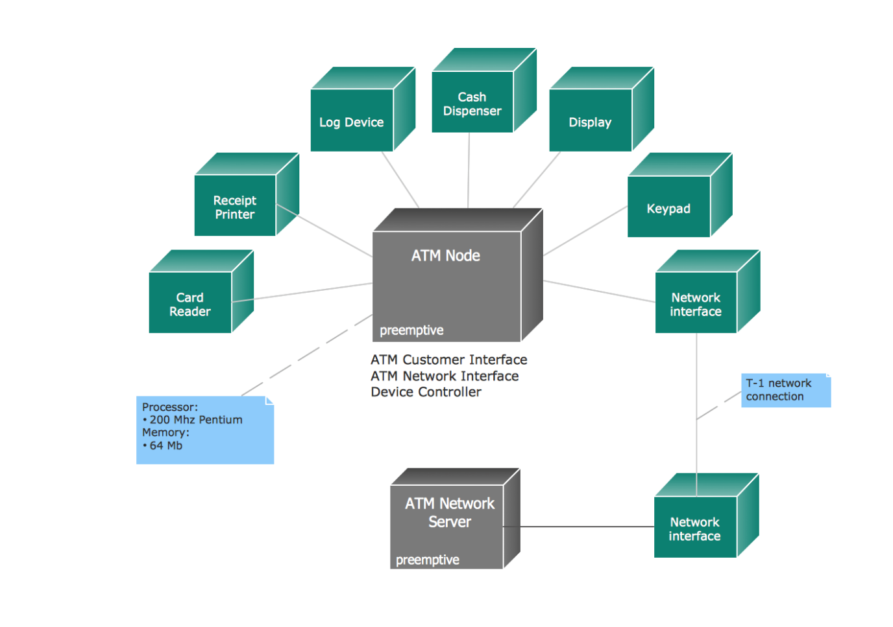

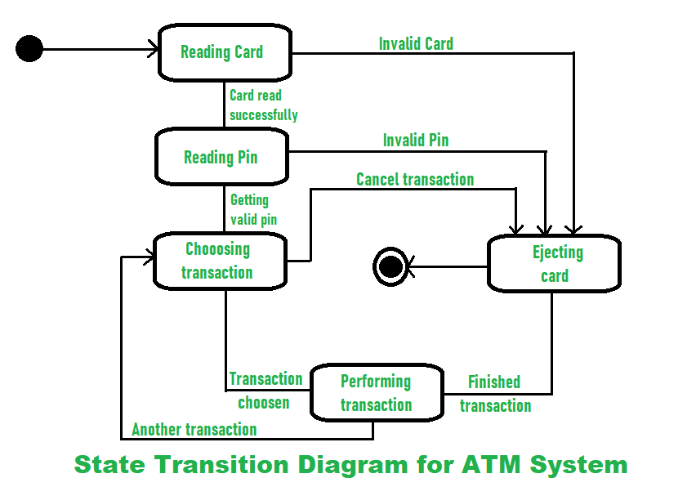

**Ui design:**

Layout design:

• **Homepage/Login Screen:**

* The first screen users encounter should be the login screen.
* Include fields for entering a username and password.
* Add a "Forgot Password" option for password recovery.
* Include a "Register" option for new users.

• **Dashboard:**

* After successful login, users should land on a dashboard.
* The dashboard should provide an overview of key ATM management metrics such as total transactions, ATM status (online/offline), cash levels, etc.
* Include graphical representations like charts and graphs for easy understanding.

• **ATM Management:**

* This section allows users to manage individual ATMs.
* Include options to view ATM status, cash levels, transaction history, etc.
* Allow for actions like cash replenishment, troubleshooting, and remote control (if applicable).

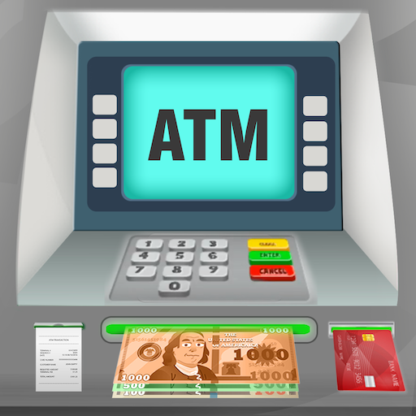



**Feasible elements in used:**

1. **Automated Transaction Tracking**: Implementing a system that tracks ATM transactions in real-time, including withdrawals, deposits, balance inquiries, and any maintenance activities, streamlining management and auditing processes.

2. **Remote Monitoring and Control**: Enabling remote monitoring of ATM status, such as cash levels, technical issues, and security alerts, allowing for proactive management and swift resolution of issues without physical intervention.

3. **Predictive Maintenance**: Utilizing data analytics and machine learning algorithms to predict potential ATM malfunctions or cash shortages based on historical data, optimizing maintenance schedules and reducing downtime.

**Implemention:**

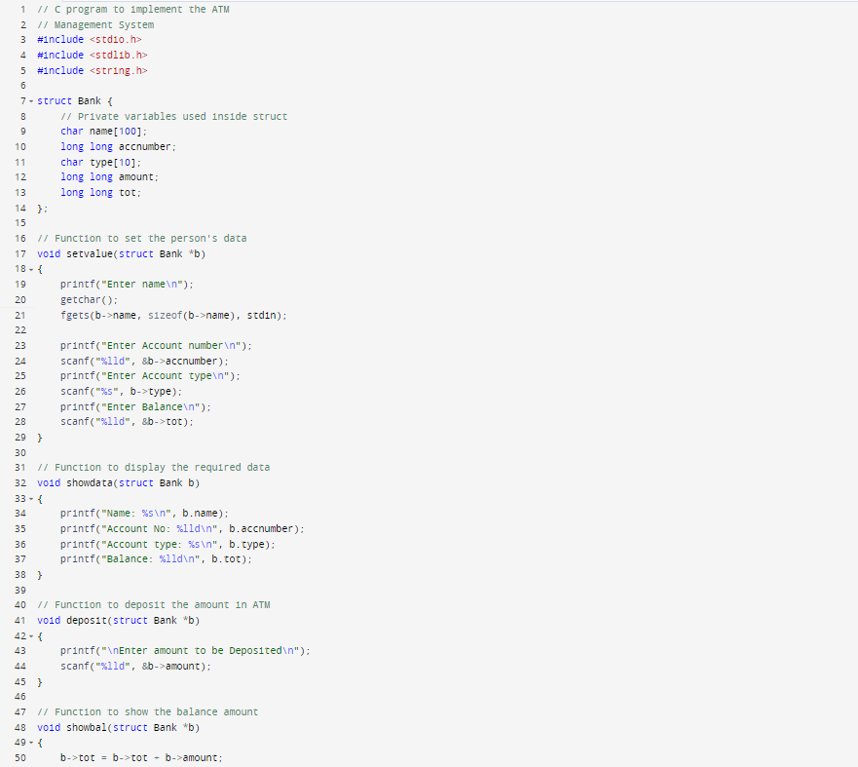

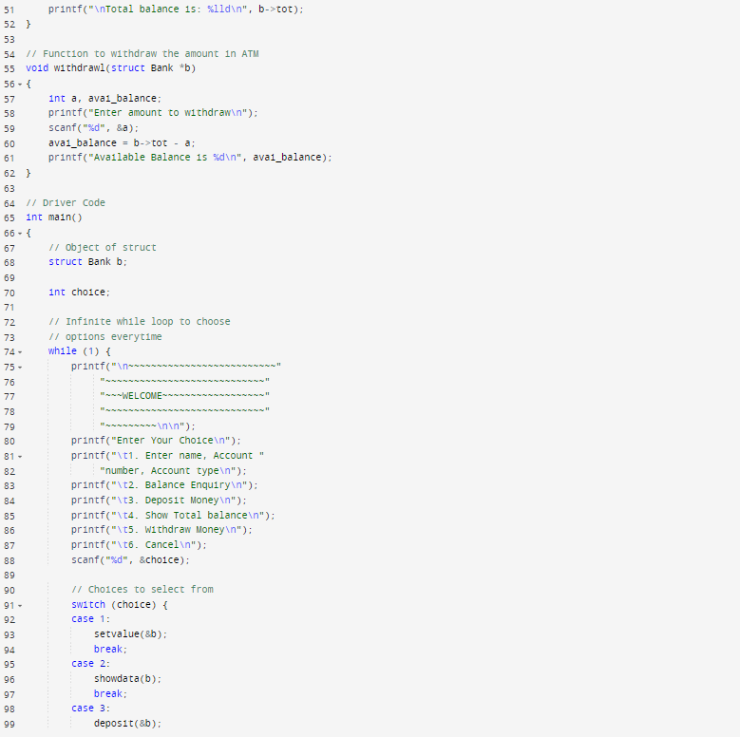

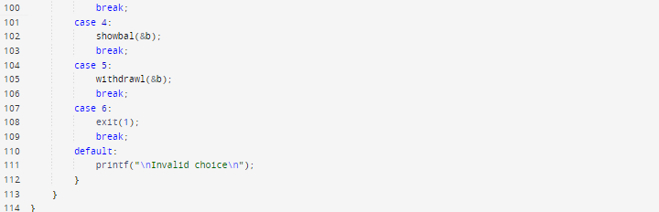

**Conclusion:**

In conclusion, the development of an ATM Management System is crucial for modern banking operations, offering efficiency, security, and convenience to customers. Through the integration of robust software and hardware components, such a system streamlines transactions, monitors cash levels, and ensures user authentication. By employing advanced data structures like hash tables, linked lists, and binary search trees, the system optimizes user management, transaction processing, and security protocols. Real-time monitoring and reporting capabilities enable banks to maintain operational integrity and respond swiftly to maintenance needs. Ultimately, the ATM Management System represents a cornerstone of contemporary banking, facilitating seamless financial transactions while upholding stringent security standards.

**References:**

1. Adams, A. & Sasse, M. A., 1999. Users are not the Enemy. Commun .. ACM 42, 12, pages 40-46. 2. Akinyemi, I., Omogbadegun, Z. & Oyelami, O., 2010. Towards Designing a Biometric Measure for Enhancing ATM Security in Nigeria Banking System ..
2. International Journal of Electrical & Computer Sciences JECS-IJENS 10, pages 68- 73 . 3. Anand, D. A., Dinesh, G. & Naveen, H. D., 2013. Reliable ATM Agreement and comparative analysis for various parameters and other ATM Protocol.
3. International Jouranl Communication and Information Technology (IJCCT), ISSN: 2278-9723, 01 (56), pages 192-197. 4. Baptiz-Lazo, B. & Barrie,. A., 2005. Business history and technology of automatic tell machine in the UK. London, Queen Mary University, page 110. 5. Das, S. & Jhunu, D., 2011.
4. Designing Biometric Strategy (Fingerprint) Measures To Strengthen ATM Security in Indian Banking System Foreign Journal of Information and Communication Technology Research, pages 197-203.